Staffed Toy Instruction

Materials needed:
- machine embroidery soft toy design and notions
- Minky, soft-n-comfy or fleece fabric
- Medium weight tear-away stabilizer

1.Put the stabilizer on the hoop with fabric or float 1st layer fabric (toy’s front) looking face up to the stabilizer in the hoop and secure it on stabiliser.
2. Stitch out all the details according to the design up to the last color.
3. Put the 2nd layer of the fabric face side to the bottom (for a toy back side) over toy’s body and stitch the line (the last color in Colors chart.).
4. Remove all from hoop and tear away excess stabilizer. Trim excess fabric along the contour of the body. For your convenience, leave bigger seam allowance around slot for staffing. Make a small cut on the sharp corners.
5. Turn toy out, put the filling and close the hole by hand in the ladder stitches.
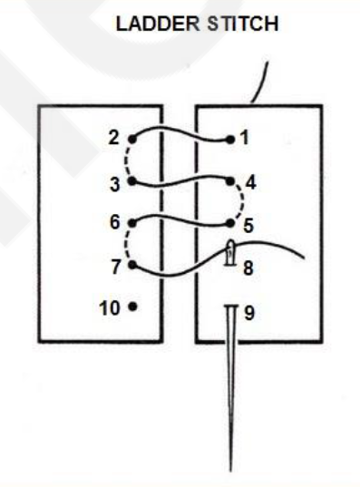
Your staffed toy is ready!

